**How to Share your Local Drive with an AWS Windows Instance**

1. Launch a new Windows Instance.

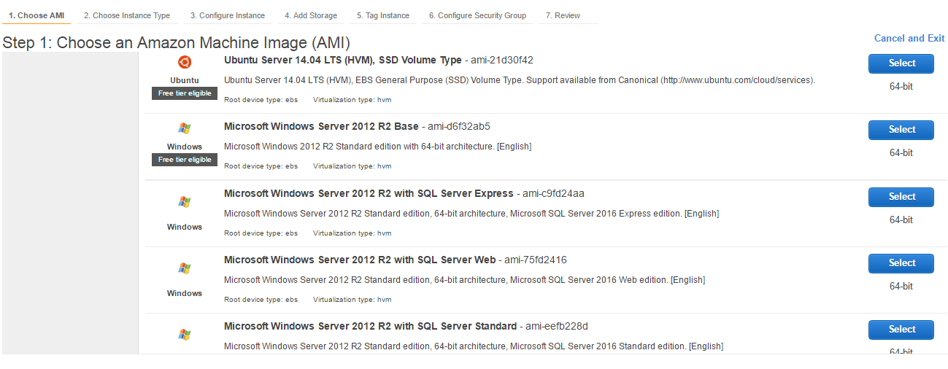

1. Ensure that you have opened the RDP port 3389 for connecting to Windows. In this example we opened it for all IP addresses but this is not best practice. create a new group or select existing one

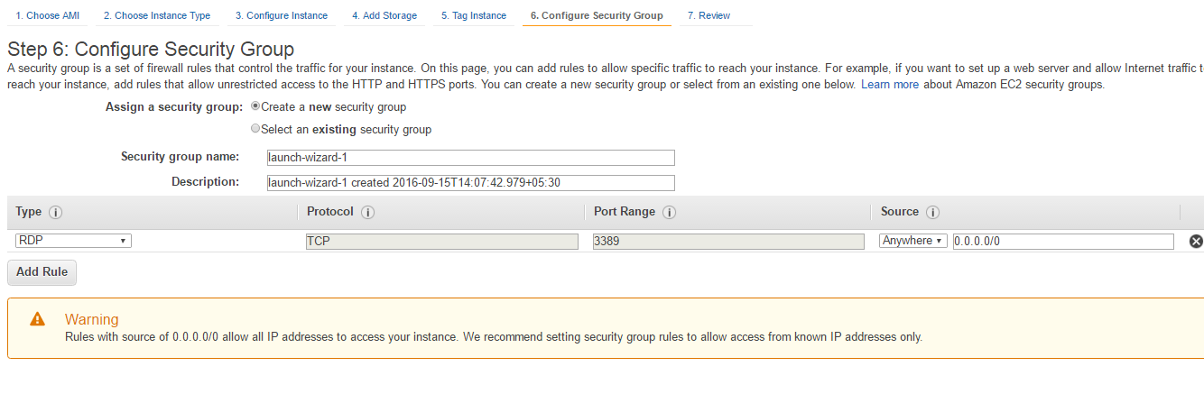

1. Verify all of the launch details

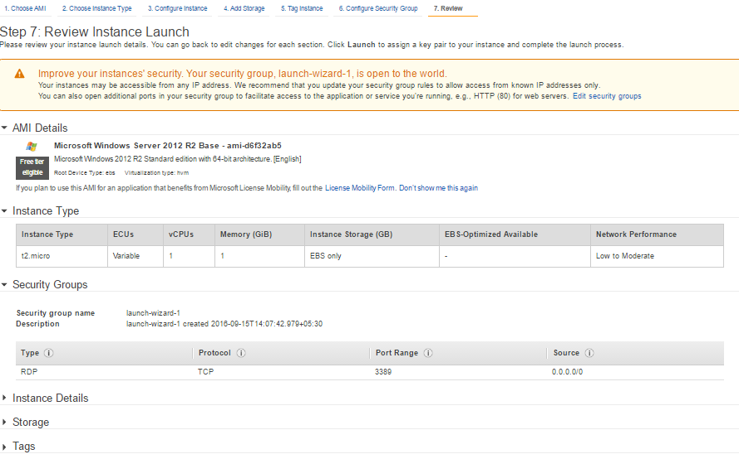

1. Once you confirm the details, the instance is launched and displayed in the console as shown below. Make note of the public DNS of the instance.

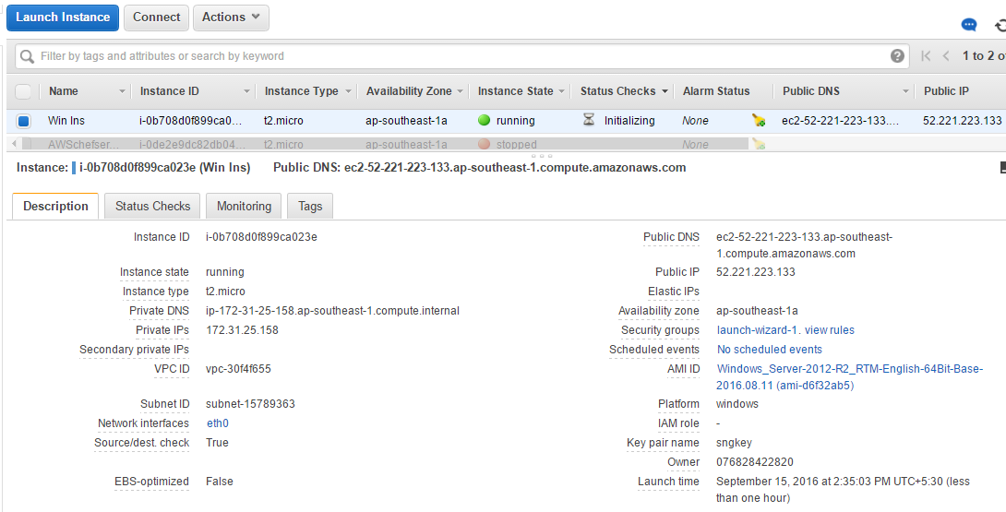

Next you will need to generate the password for this windows instance. This requires the .pem file that was created earlier and that was used to launch this instance.

1. Right-click the instance and select **Get Windows Password**. or click on action button and then select **Get Windows Password**

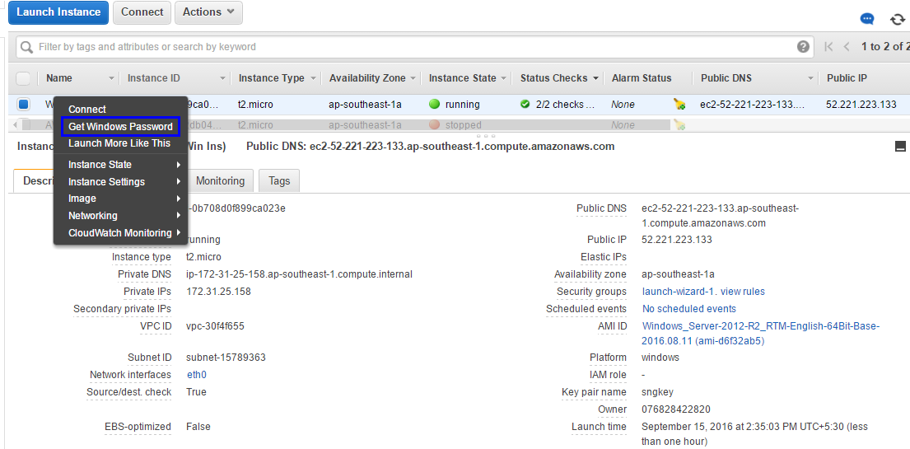

1. You are prompted to provide the details of your .pem file. Open your .pem file in notepad, copy all of the content (including – - - BEGIN RSA and – - – END RSA lines). or choose file from location and open the file then click Decrypt Passwod

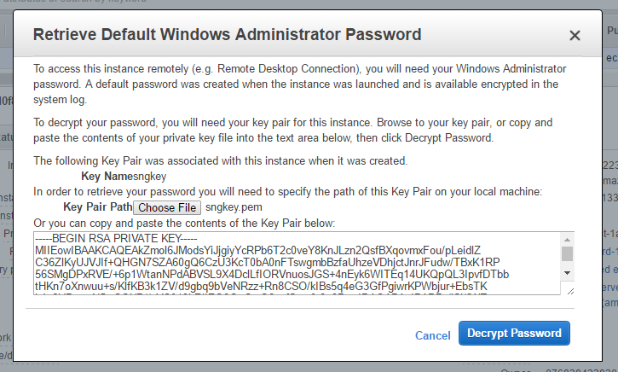

1. Click **Decrypt Password**. The decrypted password is displayed; you can use this password to connect to the Windows instance.

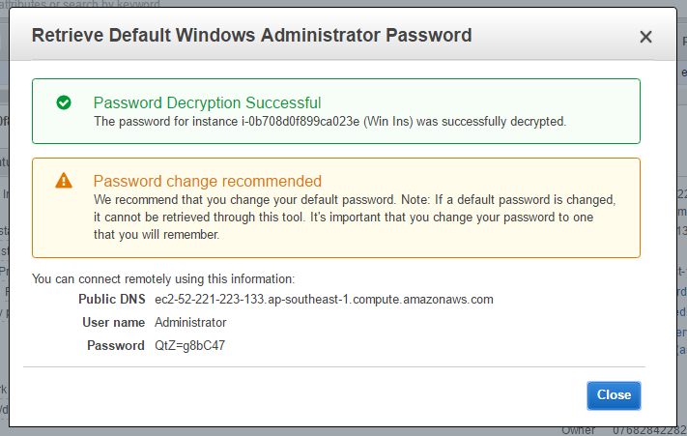

1. Store the password in a safe place, you will need to use it whenever you connect to the instance.
2. Now start the RDP (Remote Desktop Service) from the Windows machine as shown below. Run the

**mstsc** command from the Run menu.

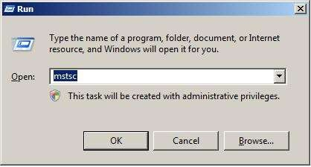

The Remote Desktop Connection window is displayed.

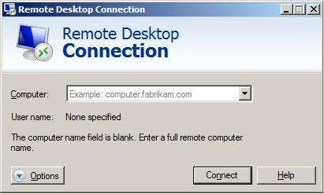

1. Click the **Options** button and then select the **Local Resources** tab.

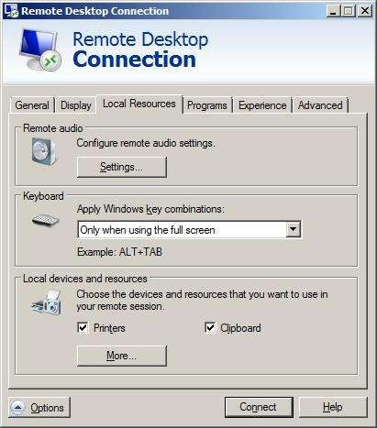

1. In the Remote audio area, select **Settings** to configure the audio settings of your instance.

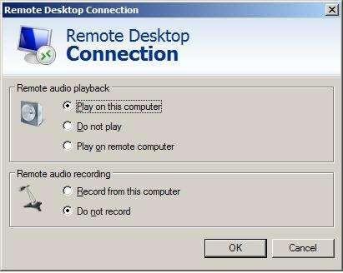

1. In the **Local Resource** tab, in the **Local devices and resources** area, click **More**. All the plug and play devices that can be available through network in the AWS EC2 server instance are listed, as well as the disk drives.

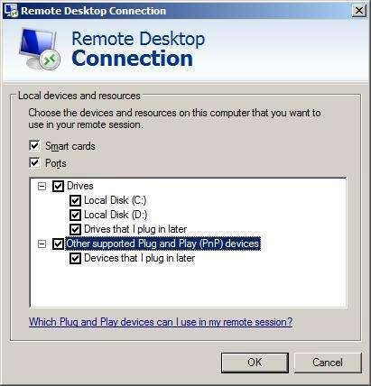

1. Select the devices and drives that you want to access from the Remote AWS EC2 server.
2. Once you have completed the above settings, provide the public DNS IP of your instance (obtained in step #4). In the **Username** field, enter administrator.

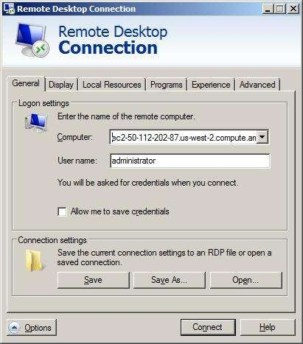

1. Click **Connect**.

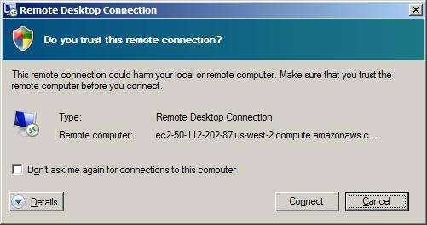

1. When prompted for confirmation, click **Connect** again. The process of connecting to the Remote Desktop (your EC2 instance running in AWS) begins. Once connected, you are prompted for the password.

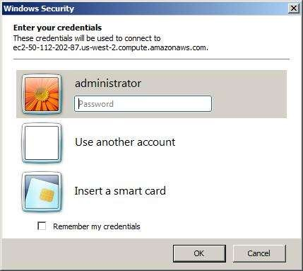

1. Provide the password you got in step#7. When you click **OK**, the password is verified and you are connected to your Windows instance.

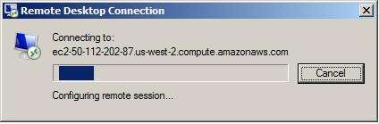

1. On first time usage, your desktop is automatically set up when you connect.

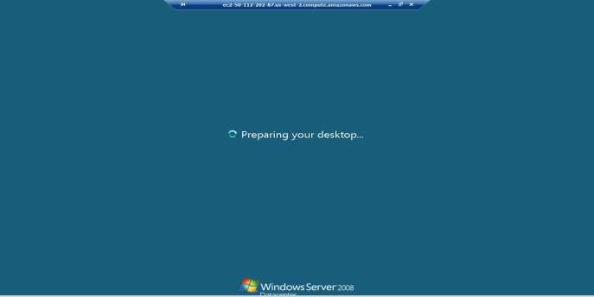

1. Once connected and setup, the desktop resembles the following:

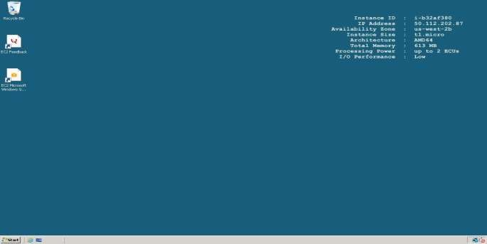

1. Open the Windows Explorer or My Computer.

The local hard disk of your desktop/laptop in the EC2 server instance is listed.

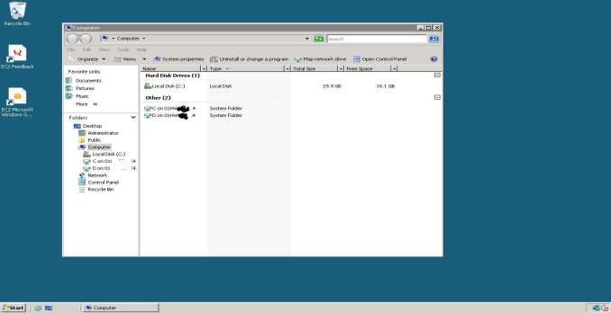

As shown above, in Windows Explorer will show both the “C” & “D” drives of your local machine. (We have masked some characters for security reasons).